**DAILY ONLINE ACTIVITIES SUMMARY**

|  |  |  |  |  |  |  |  |  |
| --- | --- | --- | --- | --- | --- | --- | --- | --- |
| **Date:** | **25/05/2020** | | | | | **Name:** | **Archana J C** | |
| **Sem & Sec** | **4th**  **‘A’** | | | | | **USN:** | **4AL18CS011** | |
| **Online Test Summary** | | | | | | | | |
| **Subject** | |  | | | | | | |
| **Max. Marks** | |  | | **Score** | | |  | |
| **Certification Course Summary** | | | | | | | | |
| **Course** | **Python machine learning** | | | | | | | |
| **Certificate Provider** | | | **Great learning academy** | | **Duration** | | | **4-5days** |
| **Coding Challenges** | | | | | | | | |
|  | | | | | | | | |
| **Status: Completed** | | | | | | | | |
| **Uploaded the report in Github** | | | | | **Yes** | | | |
| **If yes Repository name** | | | | | **archana_j_c** | | | |
| **Uploaded the report in slack** | | | | | **Yes** | | | |

Online Test Details: (Attach the snapshot and briefly write the report for the same)

* There no online test conducted

Certification Course Details: (Attach the snapshot and briefly write the report for the same)

COURSE NAME : Python machine leaning

CERTIFICATION PROVIDERS : Great learning academy

Today I leant about the user defining functions, lambda functions, classes and objectives in python and I gone through some practice programs.

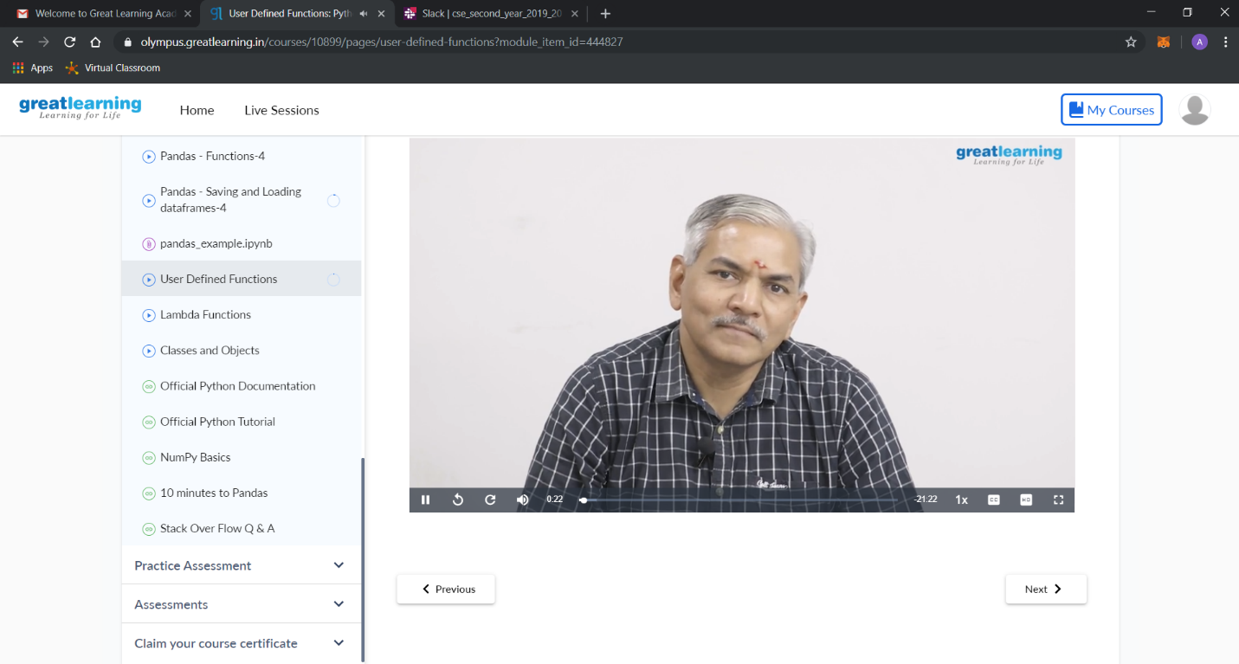

Coding Challenges Details: (Attach the snapshot and briefly write the report for the same)

Today I’m done with some python programs. The solution are already uploaded in github repository

